**Experiment 4**

**Aim :** To execute different Control structures and execute command line arguments

Write a shell script:

a) Program to calculate Gross salary of an employee.

b) To print hello world

c) Program to implement calculator using command line argument.

d) Program to find largest and smallest number among 3 numbers.

e) Menu driven program for following cases

1. To check entered number is Even odd

2. To check entered number is palindrome.

3. To check entered number is Armstrong.

**Program:**

**1 . To find the gross salary by accepting Basic salary, DA, HRA in the command line argument.**

**Code#--------------------------------------------------------------------------------------------------------------**

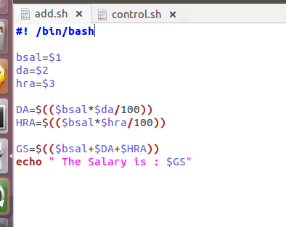

**Output####################################################################**



**2.To use the control structure and then find out which number is greater**

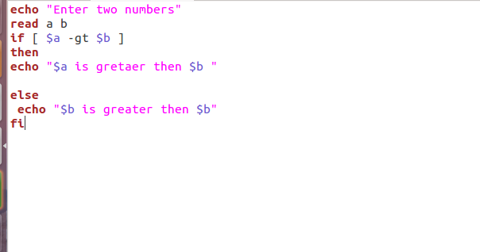

**Output######################################################################**

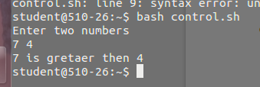

**To Compare three number using if esle condition**

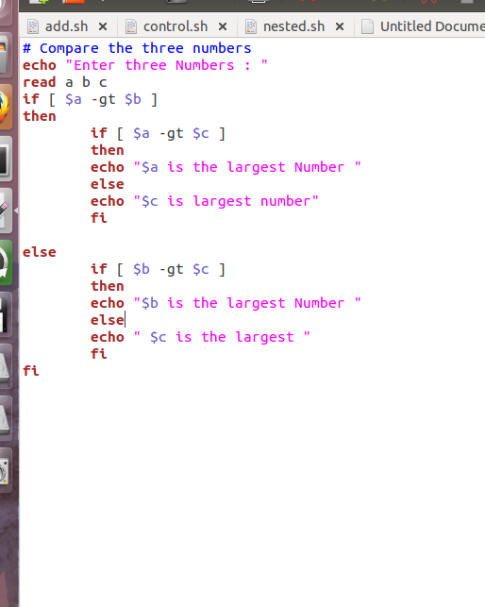

**Output**

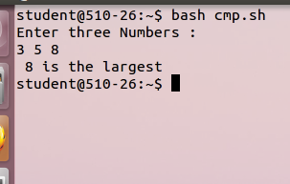

**WAP to compare three numbers using opt**

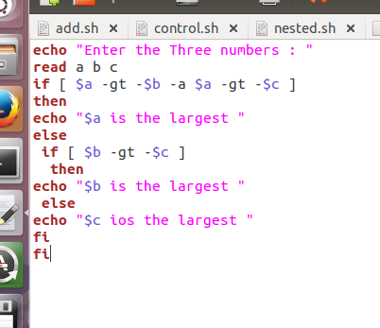

**Output######################################################################**

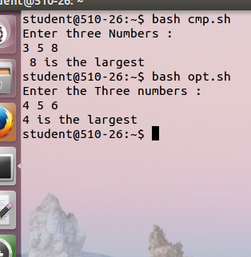

**\*\*\*\*\*\*\*\*\*\*\*\*\*\*\*\*\*\*\*\*\*\*\*\*\*\*\*\*\*\*\*\*\*\*\*\*\*\*\*\*\*\*\*\*\*\*\*\*\*\*\*\*\*\*\*\*\*\*\*\*\*\*\*\*\*\*\*\*\*\*\*\*\*\*\*\*\*\*\*\*\*\*\*\*\*\*\*\*\*\*\*\*\*\*\*\*\*\*\*\*\*\*\*\***

**Write a program for the calculator**

**Code ##################################################################**

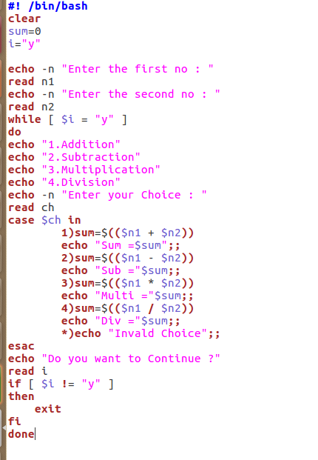

**Q. Armstrong Number**

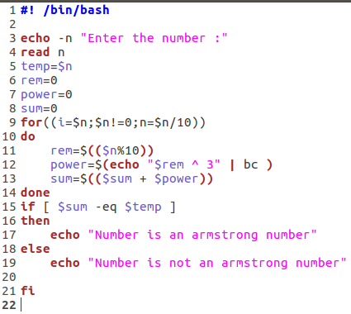

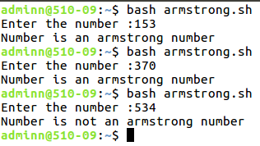

**>Menu driven program to check if entered number is**

**a.Even Odd**

**b.Prime**

**c.Palindrome**

|  |
| --- |
| **#!/bin/bash**  **clear**  **i="y"**  **while [ $i = "y" ]**  **do**  **echo "1:Even or odd"**  **echo "2:Prime"**  **echo "3:Palindrome"**  **echo -n "Enter your Choice : "**  **read ch**  **case $ch in**  **1)**  **echo -n "Enter the number: "**  **read n1;**  **if [ $(($n1%2)) -eq 0 ]**  **then**  **echo "The Number is even"**  **else**  **echo "The number is odd"**  **fi;;**  **2)**  **echo -n "Enter a number: "**  **read num**  **i=2**  **while [ $i -lt $num ]**  **do**  **if [ `expr $num % $i` -eq 0 ]**  **then**  **echo "$num is not a prime number"**  **# echo "Since it is divisible by $i"**  **exit**  **fi**  **i=`expr $i + 1`**  **done**  **echo "$num is a prime number "**  **;;**  **3)**  **echo "Enter the number to check whether the enterd number is pallindrome or not"**  **read num**  **sd=0**  **rev=""**  **on=$num**  **while [ $num -gt 0 ]**  **do**  **sd=$(( $num%10 ))**  **num=$(( $num/10 ))**  **rev=$( echo ${rev}${sd} )**  **done**  **if [ $on -eq $rev ];**  **then**  **echo "Number is palindrome"**  **else**  **echo "Number is not palindrome"**  **fi**  **;;**        **\*)echo "Invalid choice";;**  **esac**  **echo "Do you want to continue ?"**  **read i**  **if [ $i != "y" ]**  **then**  **exit**  **fi**  **done** |

**Output:**

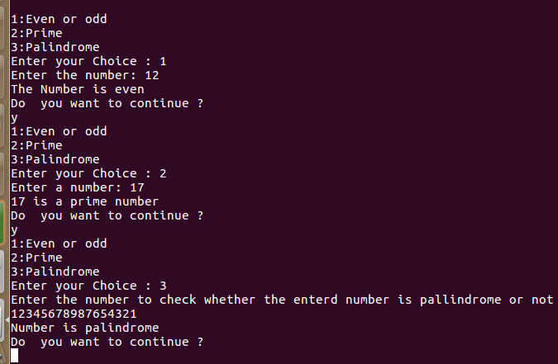

**Conclusion:**We have successfully executed different Control structures and executecommand line arguments